Git challenges
1 Resolve Merge Conflicts
Resolving merge conflicts in Git is simply the process of manually correcting a file where Git couldn't automatically figure out which changes to keep when combining two branches, then telling Git the fix is done.
Step 1: Create a folder & initialize Git
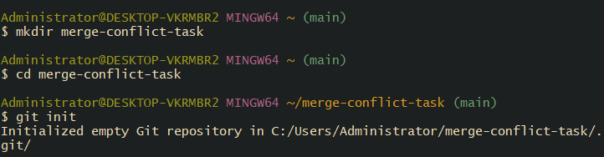

Step 2: Create a file on main branch
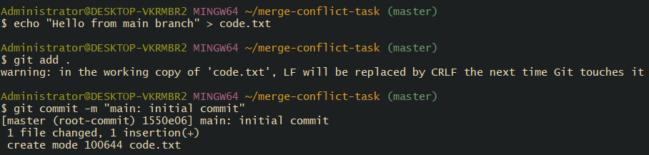
Step 3: Create a new branch
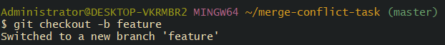
Step 4: Edit the file differently in feature branch
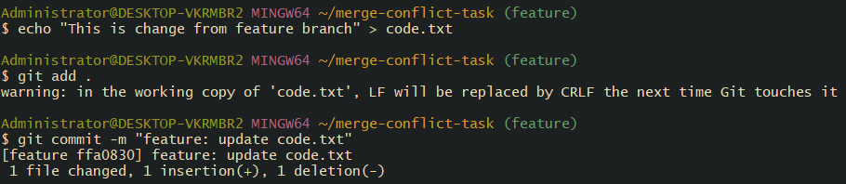
Step 5: Switch back to main in case already switch
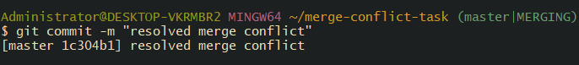
Step 6: Make a conflicting change in main
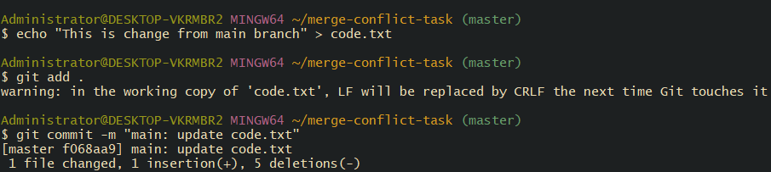
Step 7: Merge the feature branch - conflict will appear
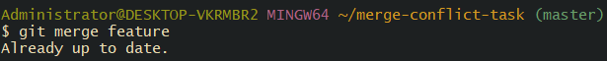
You will get a merge conflict message
because code.txt was edited differently in both branches.
STEP 8 — Open code.txt
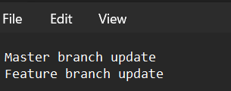 And update it
STEP 9 — Fix the file
STEP 10 — Mark as resolved
STEP 11 — Finish merge
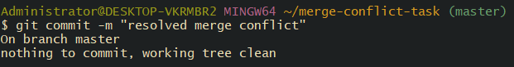
successfully created & resolved a merge conflict!
2. Recover Deleted Branch
STEP 1 — Create a branch
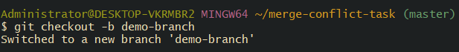
After this add something inside in demo.txt in my case i have added “ this is demo branch file “
STEP 2 — Switch back to master
STEP 3 — Delete the branch
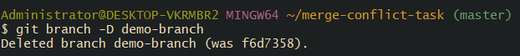 now we deleted our branch
STEP 4 — Find deleted branch commit using reflog
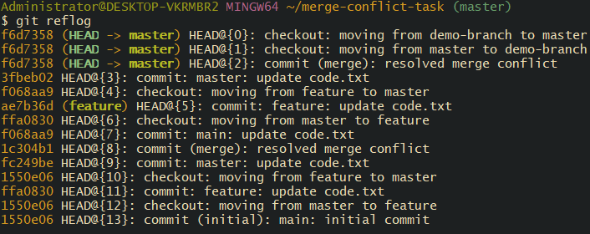
STEP 5 — Recover the deleted branch
STEP 6 — Recover the branch
Copy that commit ID (example: abcde12). In my case it is 19f04d9
branch is recovered!
Then verify: you see in our kernal
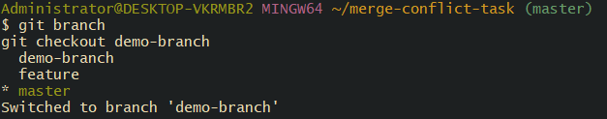

3. Undo Wrong Push

STEP 1 — Check your commit history
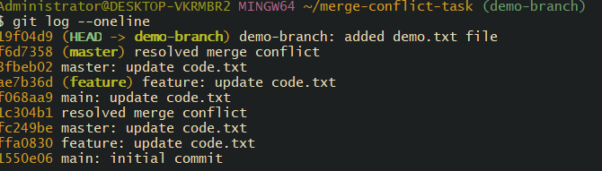
STEP 2 — Reset your branch to the previous good commit
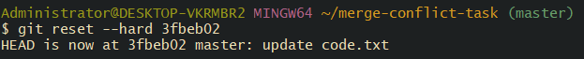
Step 3 Now we are Undo Wrong Push with simple step by step
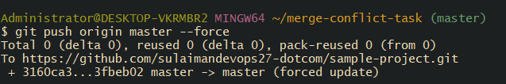

4. Amend a Commit
1) Work normally — make the first commit
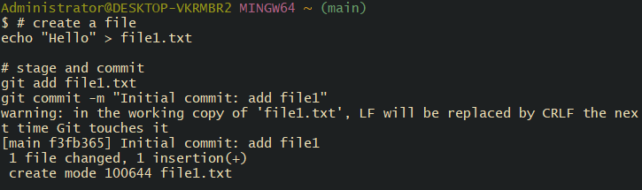
Check the commit: 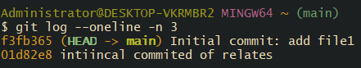

2) Realize you forgot a file (the missing file)
Create or edit the missing file: 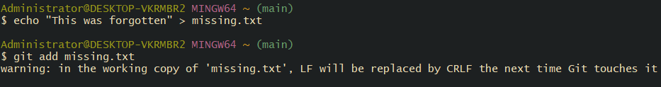
3) Amend the previous commit to include the missing file
If you want to keep the same commit message:
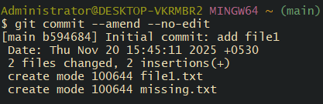 What this does: it replaces the last commit with a new commit that contains whatever is currently staged (file1.txt + missing.txt), preserving the previous commit message.
After amend, verify:
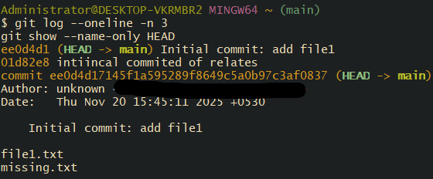

5: Cherry-pick a Commit
- Create a new branch
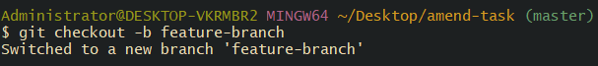
- Get the commit ID:
In my case its 07e2216
- Switch to the master branch ( master is defult branch )
- Cherry-pick the commit
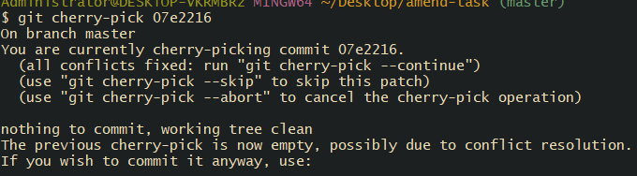 paste the code been copy from commid id paste here
- Verify

6 Interactive Rebase
STEP 1 — Make a fresh folder
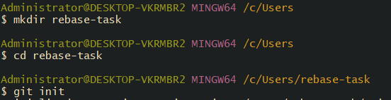
STEP 2 — Create 3 commits
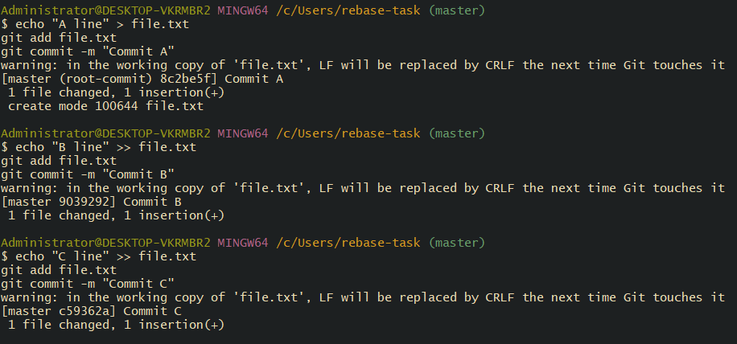
Check log:
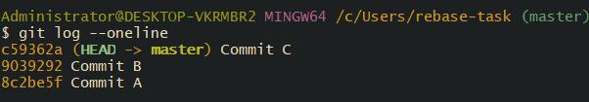
STEP 3 — Start Interactive Rebase for last A commits
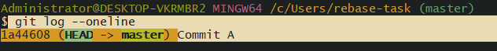

7 Tagging & Release

Step 1 — Create a Lightweight Tag
in my case im using git tag v1.0
Step 2 — Create an Annotated Tag
you can write any message
Step 3 — Verify the Tags
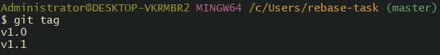

Step 4 — Checkout a Tag
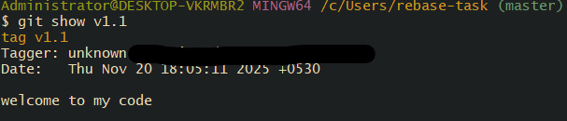

Step 5 Adding This Remote
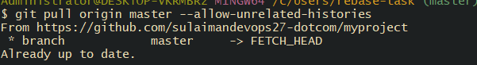

Step 6 — Verify on GitHub clean, commits are squashed, and release tags are pushed.
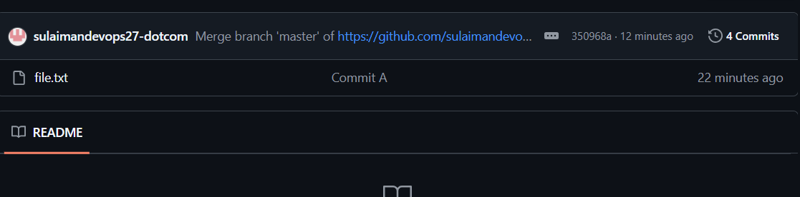

8. Clone with Sparse Checkout
1. Clone the repository without checking out files
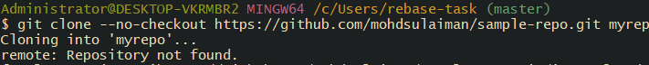
2. once u clone it u get repository without downloading or waiting too long time just you need type git clone < url > press enter within second it clone it
3 Pull updates

9 Reset vs Revert Challenge
- git reset --hard resets your current branch to a specific commit and completely discards all changes in the staging area and working directory.
- git log -5 is a shortcut to see the last 5 commits in your Git history.
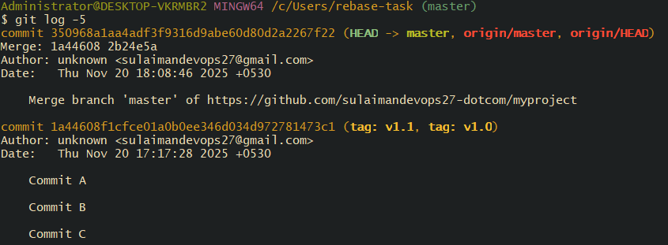
Using git revert command to edit the commit
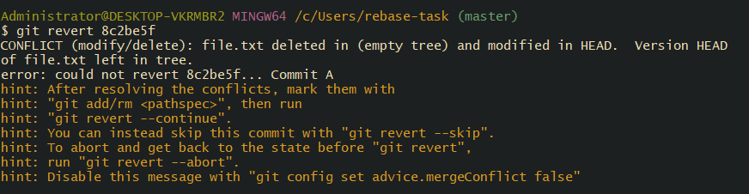
- Detached HEAD Challenge
Git long –oneline shows you a list of all your past saves (commits) but condenses every save into just one single line so you can see the history quickly.

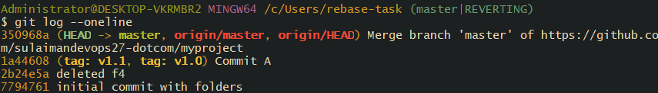
Switched to the target branch using git checkout. Step 4: Listed all available branches using git branch.
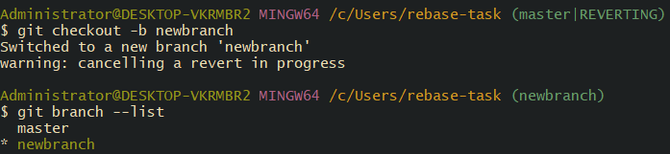

- . Squash Merge vs Rebase Merge
- squash
Definition:
Squash Merge takes all commits from a feature branch and combines them into a single commit before merging into the target branch (usually main or master).

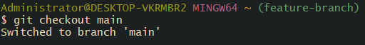

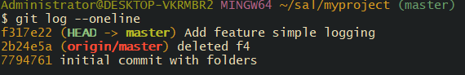
main gets one commit only.

- What is Rebase Merge
Rebase = replay commits from your branch on top of main
Step 1 — Switch to your feature branch

STEP 2 — Make some commits
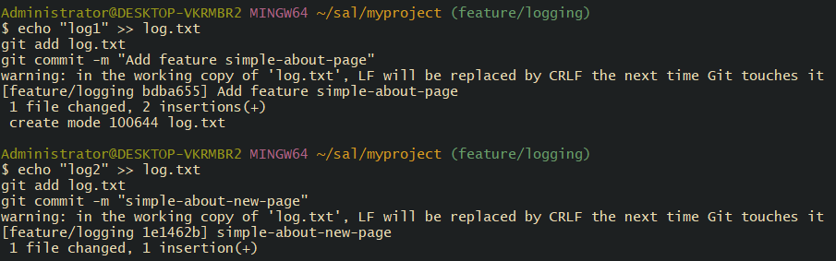

Pull latest master (optional if local only)
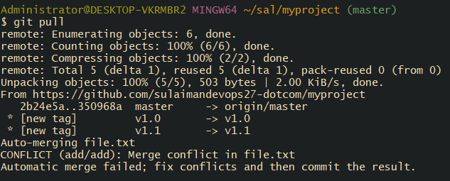

Step 3) Complete the merge

12 Fork & Pull Request Workflow
You will fork someone else's repository, make changes on your copy, and then create a Pull Request (PR) so the original repo owner can merge your changes.
- Find a Repository to Fork in case
https://github.com/octocat/Spoon-Knife
2️ Click “Fork”

Now click 
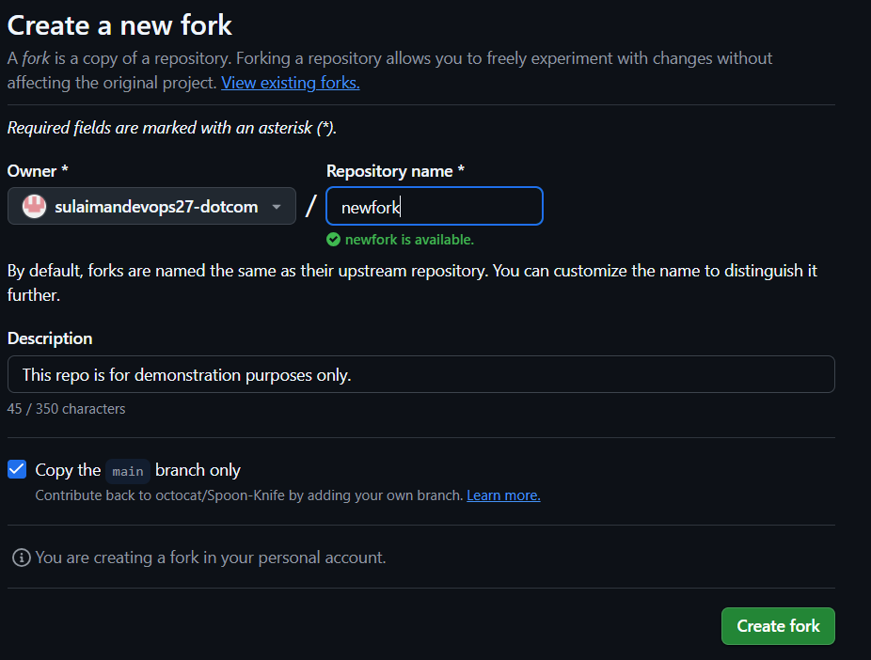
Now give any repository name after simple click create fork
- Clone it
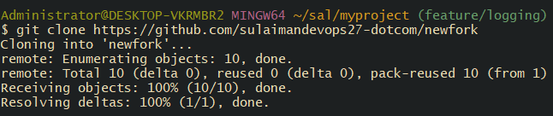

Enter repo:

4 Add New Remote for Original Repo (Upstream)
Check remotes:
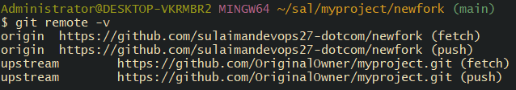
5 Create a New Branch

6 Add & Commit
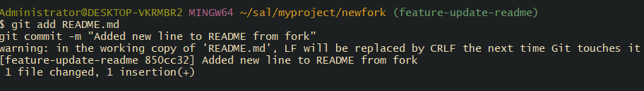
7 Push Your Branch to GitHub
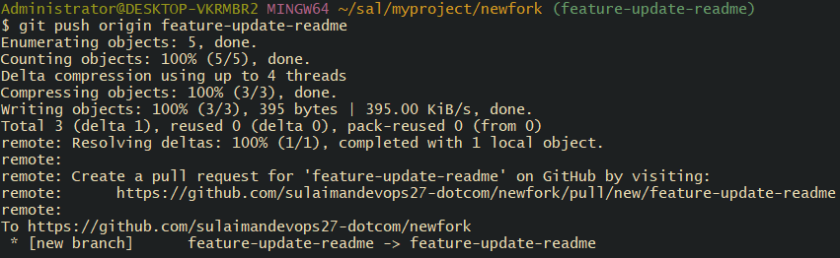
8 Create Pull Request (PR)
You will see this on your dash board . just click on campare & pull request
1Title: Added new line in README
2 Description: what you change
Then click on create pull request

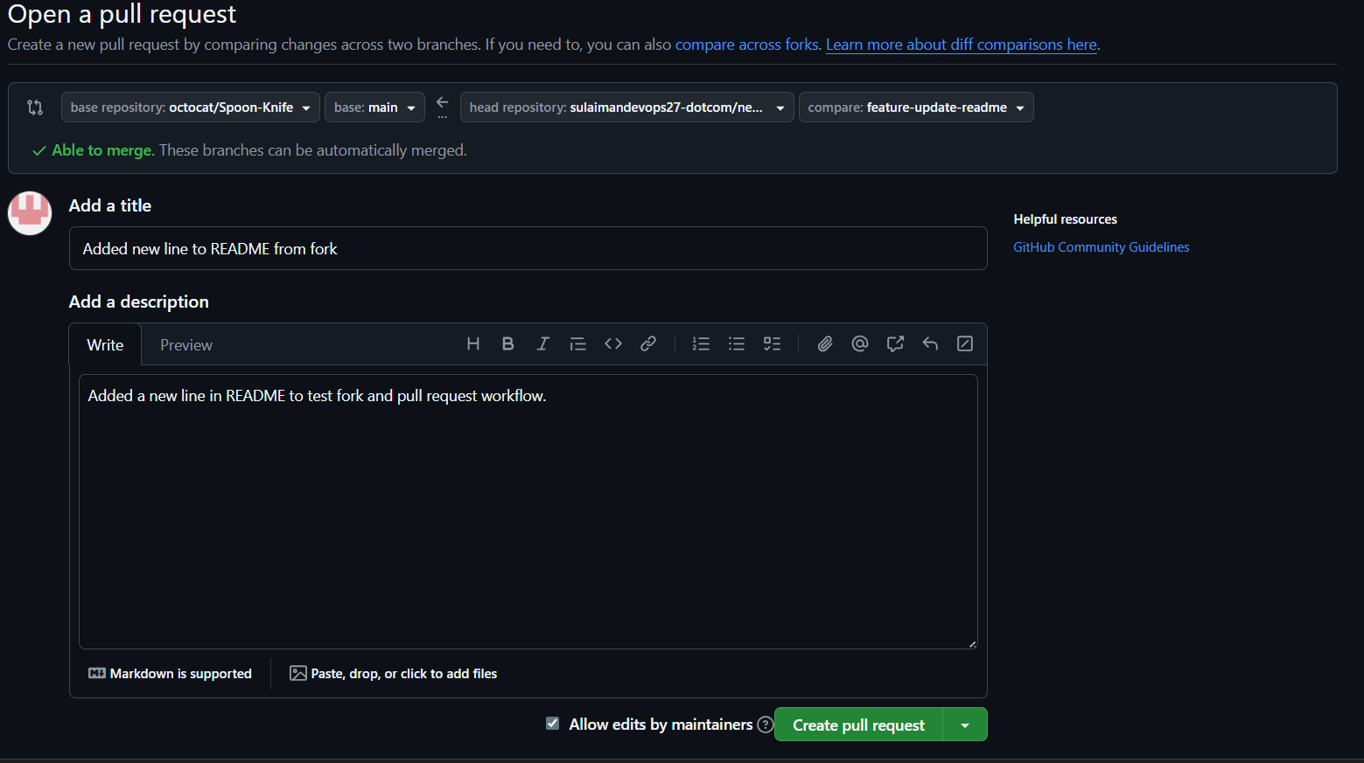
Now we have successfully done Fork → Change → Push → Pull Request

13 Recover lost commit
Step 1: view history (even deleted commits In my case deleteing d0dd1f6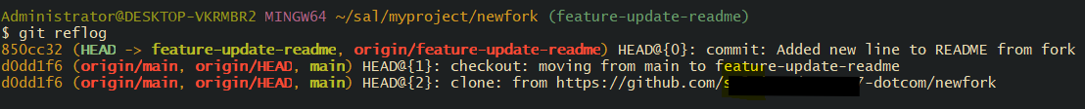
Step2: Checkout the lost commit
Git checkout your commit hash
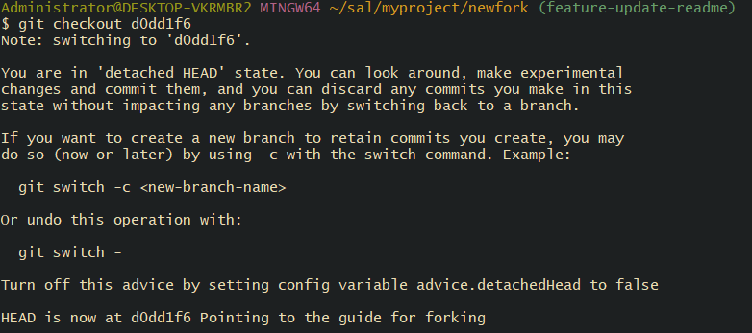

Step3 commit recovered

Thank you for reviewing!

